Quick start

Google Colab notebook https://colab.research.google.com/drive/1NyW5Qc0hWue9g-9oz36y-Gw4WrCiiPUl?usp=sharing

1. Copy the notebook to your drive
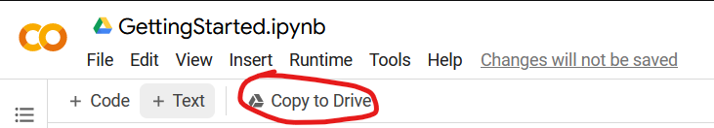

2. Implement your solution in cells 1, 2, 3, 4
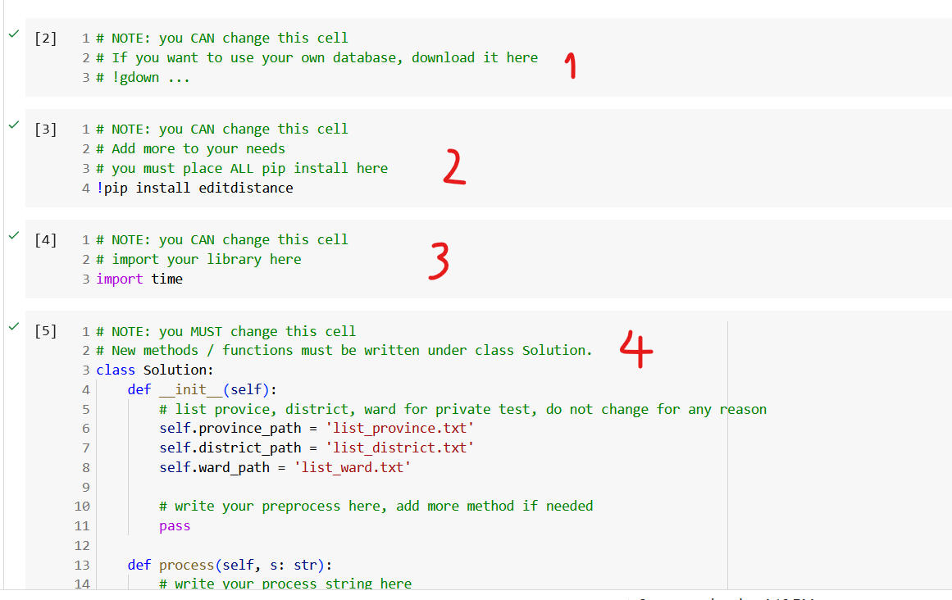

Rules to make things easier for the grading process:
- Cell 1: for downloading your own database, or indexes, …
- Using gdown for downloading files from your drive to the notebook.
- Your file must be shared under “anyone with the link can view this file”.
- Your shared file must exist past the grading period. If your notebook depends on your drive files and it does not exist during the grading process, you get a zero (because your notebook cannot run).
- DO NOT connect to your own drive in the submission file

- Cell 2: for pip install libraries
- Cell 3: for importing libraries
- Cell 4: class Solution
- Every new method you write must be placed under this class
- The preparation must be in __init__() and the answer to each address must be in process()
- The last 2 cells: Scoring cells, will be replaced at grading time.
- Failure to follow these steps may or may not result in a zero.

3. Press Ctrl-F9 to Run all

4. Your score will display below the last cell (also, there is a detailed .xlsx file for your convenience)
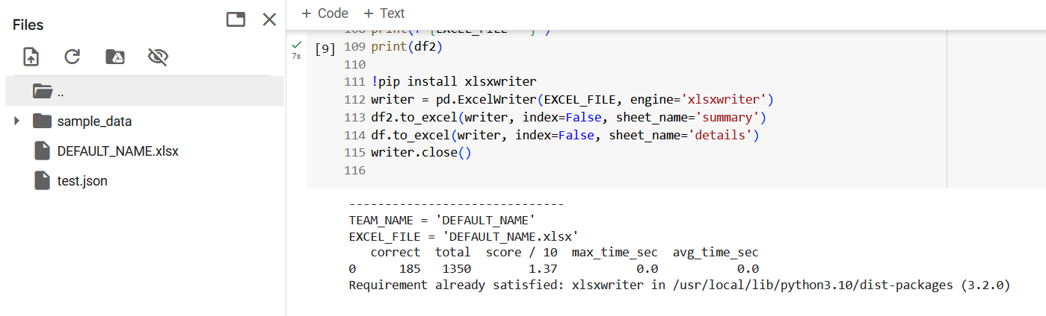

5. When you are completed with your solution, click clear all outputs, then submit BOTH the .ipynb file and the .py file
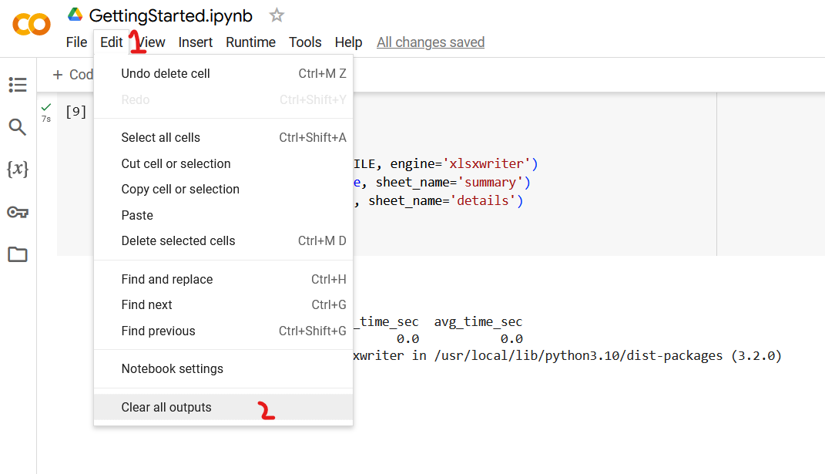
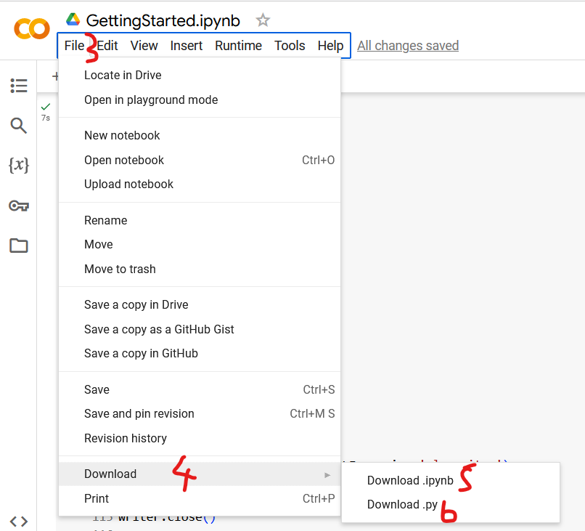

6. Submit your file to BKEL
Link nộp bài: Thông báo sau

The grading process
The next-to-last cell will be replaced with the private test.
Then the .ipynb file (the notebook) is run from the top to bottom using Run all (Ctrl F9)
If the notebook fails twice, you get a zero, it's the score on the last cell output

Q&A

The format of 3 files: “list_province.txt”, “list_district.txt”, “list_ward.txt” ?
- All 3 files have the same format
- Each file contains multiple lines, each line contains a single string which is the name of an administrative division, without the unit prefix

Example:

list_province.txt (without backticks)
```
Hà Nội
Hồ Chí Minh
Bình Dương
```
-> this province list contains 3 names, each of which is a city or a province

Samples (For format only, the real database will be released later):
list_ward: https://drive.google.com/file/d/18FJEerNFY_RcXKccpR6f71YYD7KkiuLx/view?usp=drive_link
list_province:
https://drive.google.com/file/d/1qcW6_YiLGg6w355ZRonW1eCTles3NRED/view?usp=drive_link
list_district:
https://drive.google.com/file/d/1hp43CtZr_3UqKb2gw3vrlymEdC-7bVeI/view?usp=drive_link

Does the test always contain a real address?
Yes.
So it does NOT have the case like “Quận Hai Bà Trưng, Thành phố Hồ Chí Minh” (because Hai Bà Trưng is a district in Hà Nội city)

Be prepared that the private test will contain both 3 levels and 2 levels addresses

